**PREDICTION CHURN CUSTOMER**

Some of the techniques used for this purpose include:

* KNN (K-Nearest Neighbors)
* SVM (Support Vector Machine)
* Decision Tree
* Random Forest[**1**](https://www.bing.com/ck/a?!&&p=7c81bf5ea7f35e71JmltdHM9MTY5Njg5NjAwMCZpZ3VpZD0yMmEyNDAzYi01YTYwLTZhMDItMzc0MC01MjE0NWJiMjZiNzMmaW5zaWQ9NTcyMA&ptn=3&hsh=3&fclid=22a2403b-5a60-6a02-3740-52145bb26b73&psq=prediction+churn+customer+what+are+the+machine+learning+techniques&u=a1aHR0cHM6Ly9pZWVleHBsb3JlLmllZWUub3JnL2RvY3VtZW50LzkyOTc1Mjk&ntb=1)

[Amazon SageMaker can be used to **analyze customer churn probability using call transcription and customer profiles**](https://www.bing.com/ck/a?!&&p=dd3aa8c1ad2d8b62JmltdHM9MTY5Njg5NjAwMCZpZ3VpZD0yMmEyNDAzYi01YTYwLTZhMDItMzc0MC01MjE0NWJiMjZiNzMmaW5zaWQ9NTcyMQ&ptn=3&hsh=3&fclid=22a2403b-5a60-6a02-3740-52145bb26b73&psq=prediction+churn+customer+what+are+the+machine+learning+techniques&u=a1aHR0cHM6Ly9hd3MuYW1hem9uLmNvbS9ibG9ncy9tYWNoaW5lLWxlYXJuaW5nL3ByZWRpY3RpbmctY3VzdG9tZXItY2h1cm4td2l0aC1hbWF6b24tbWFjaGluZS1sZWFybmluZy8&ntb=1)[**2**](https://www.bing.com/ck/a?!&&p=1d441e0924b06babJmltdHM9MTY5Njg5NjAwMCZpZ3VpZD0yMmEyNDAzYi01YTYwLTZhMDItMzc0MC01MjE0NWJiMjZiNzMmaW5zaWQ9NTcyMg&ptn=3&hsh=3&fclid=22a2403b-5a60-6a02-3740-52145bb26b73&psq=prediction+churn+customer+what+are+the+machine+learning+techniques&u=a1aHR0cHM6Ly9hd3MuYW1hem9uLmNvbS9ibG9ncy9tYWNoaW5lLWxlYXJuaW5nL3ByZWRpY3RpbmctY3VzdG9tZXItY2h1cm4td2l0aC1hbWF6b24tbWFjaGluZS1sZWFybmluZy8&ntb=1). [It can also be used to **build, tune, and deploy an end-to-end churn prediction model using Amazon SageMaker Pipelines**](https://www.bing.com/ck/a?!&&p=932b1e70b98350a9JmltdHM9MTY5Njg5NjAwMCZpZ3VpZD0yMmEyNDAzYi01YTYwLTZhMDItMzc0MC01MjE0NWJiMjZiNzMmaW5zaWQ9NTcyMw&ptn=3&hsh=3&fclid=22a2403b-5a60-6a02-3740-52145bb26b73&psq=prediction+churn+customer+what+are+the+machine+learning+techniques&u=a1aHR0cHM6Ly9hd3MuYW1hem9uLmNvbS9ibG9ncy9tYWNoaW5lLWxlYXJuaW5nL3ByZWRpY3RpbmctY3VzdG9tZXItY2h1cm4td2l0aC1hbWF6b24tbWFjaGluZS1sZWFybmluZy8&ntb=1)[**2**](https://www.bing.com/ck/a?!&&p=5328b205261be743JmltdHM9MTY5Njg5NjAwMCZpZ3VpZD0yMmEyNDAzYi01YTYwLTZhMDItMzc0MC01MjE0NWJiMjZiNzMmaW5zaWQ9NTcyNA&ptn=3&hsh=3&fclid=22a2403b-5a60-6a02-3740-52145bb26b73&psq=prediction+churn+customer+what+are+the+machine+learning+techniques&u=a1aHR0cHM6Ly9hd3MuYW1hem9uLmNvbS9ibG9ncy9tYWNoaW5lLWxlYXJuaW5nL3ByZWRpY3RpbmctY3VzdG9tZXItY2h1cm4td2l0aC1hbWF6b24tbWFjaGluZS1sZWFybmluZy8&ntb=1).

**1. Establish the Business Case**

This step is simply understanding your desired outcome from the ML algorithm. In this case, the final objective is:

* Prevent customer churn by preemptively identifying at-risk customers
* Design appropriate interventions to improve retention

**2. Collect and Clean Data**

The next step is data collection — understanding what data sources will fuel your churn prediction model. Companies [**capture customer data**](https://www.scalr.ai/post/data-capture-services) across their lifecycle through software such as CRM, web analytics, sentiment analysis tools, social listening tools, customer service software, and more.

Building data capture services is one of the easiest and most effective ways to begin collecting data to power your churn prediction model. Turnkey solutions like automated data capture (ADC) can help you leverage your existing software to speed up relevant data collection and apply it to your churn prediction model. ADC eliminates the manual efforts required for data entry and frees up time for your data team to fine-tune your prediction model.

**3. Engineer, Extract, and Select Features**

Feature engineering is a crucial part of the dataset preparation — it helps determine the attributes that represent behavior patterns related to customer interaction with a product or service. Data scientists use feature engineering to assign measurable characteristics to data points that an ML model will process to predict churn probability.

These features could include customer demographics, behaviors (in the mobile phone example, these could be data consumption, calling customer service, using international roaming, etc.), and contextual features that describe other information about a customer like communication preferences, past buying behavior, or birthdays/anniversaries.

Next, feature extraction standardizes the variables (attributes) by only isolating the ones that contain meaningful information in context of the business case (churn). Feature extraction limits data dimensionality (columns representing attributes in a dataset) and only retains helpful data for the business case.

**4. Build a Predictive Model**

Data analysts typically approach churn prediction using multiple methods such as binary classification, logistic regression, decision trees, random forest, and others.

ML algorithms perform binary classification to slot the attributes of a target variable into two groups on the basis of a classification rule. In this context, the target variable is churn, the outcome of which can be classified as true or false. Binary classification helps us understand which customers churned and which ones stayed on.

Based on this information, data scientists can then run regression analysis to determine the relationship between the target variable (churn) and other data points that influence churn (monthly plan, data consumption, service calls, etc.), in weighted values.

This will provide information on whether variables have a positive or negative relationship with churn. A positive relationship indicates a higher probability for customers to leave and a negative relationship means that customers are less likely to churn.

A decision tree is yet another effective training model for churn prediction. The decision tree model uses available features and splits the data based on features values to provide unique resulting groups. Here’s a simple example of a decision tree:

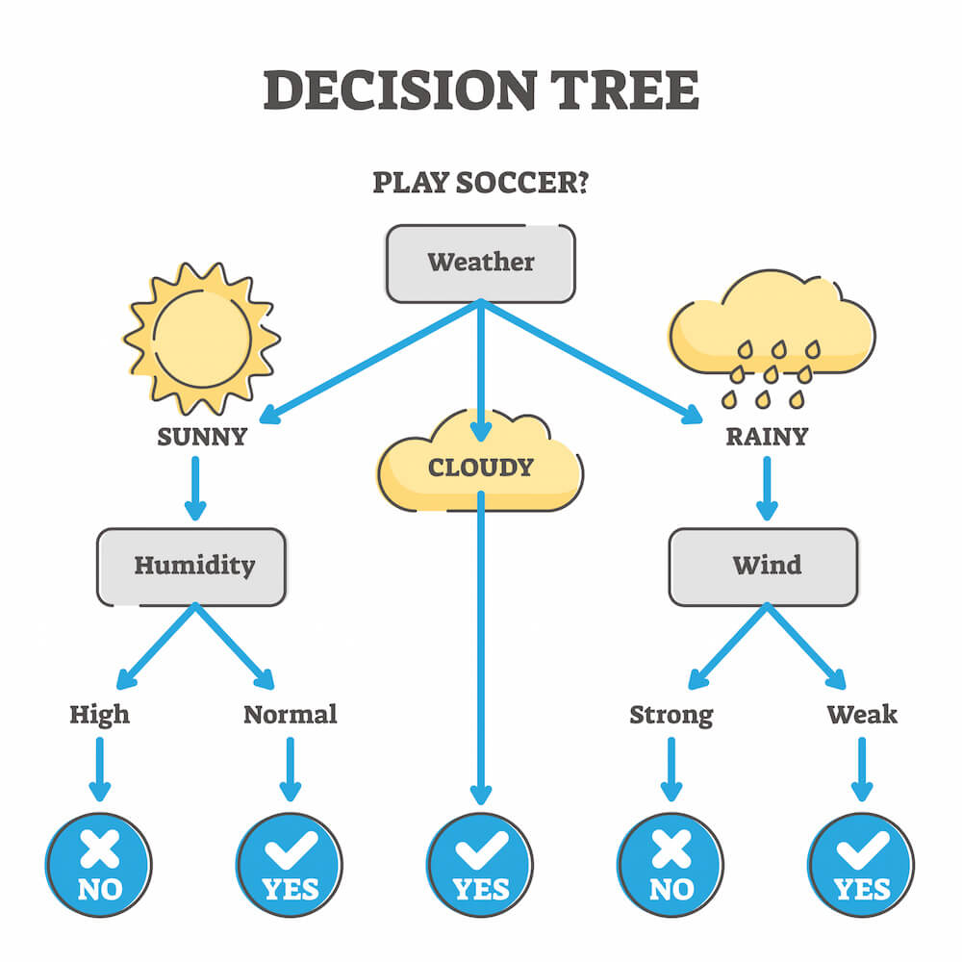

Now, depending on the size of the dataset and the diversity of feature data, you may choose to use multiple decision trees or a Random Forest.

A Random Forest is a collection of multiple decision trees, where each individual tree splits out a classification. These classifications are binary in nature, so whichever classification receives the most number of votes, wins. So, if your Random Forest consists of five decision trees, and three of those provide the same classification, your final prediction will be determined by the majority.

**5. Deploy and Monitor**

Once you have developed the model, it needs to be integrated with existing software or serve as the base for a new program or application. You’ll need to pay close attention to the model’s accuracy and performance.

Testing and monitoring model performance to adjust features will help improve the model’s accuracy. From our mobile services example, monitoring and testing could mean logging customer interactions and reviews.

